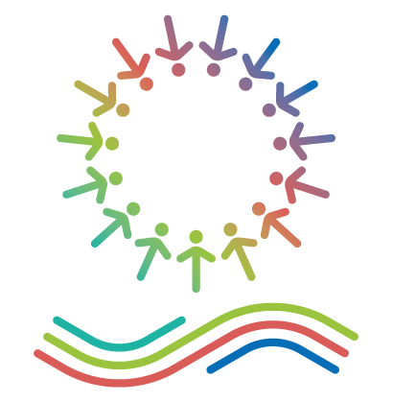

Interreg NEXT MED Programme
Release Form
“Find the Mediterranean in your city” Photo Contest

Interreg NEXT MED Photograph Contest

Find your city in the Mediterranean – 2023 Mediterranean Day

Release Form
This photograph release form is made on [INSERT DATE] between:
The Releasor, [INSERT NAME OF THE PHOTOGRAPHER], located at [INSERT ADDRESS OF THE PHOTOGRAPH].
The Releasee, the Interreg NEXT MED Programme Branch Office for the Western Mediterranean, located in C/Caballeros, 9 - 46001 Valencia, Spain.

I, [INSERT NAME OF THE RELEASOR], hereby agree and consent on the following:
- The Releasee will be free to use the photograph taken on [INSERT DATE IN WHICH THE PHOTOGRAPHS WERE TAKEN] and submitted to the Releasee in the framework of the Interreg NEXT MED Programme Photo Contest “Find the Mediterranean in your City”, in any type of non-profit publication, including print or web-based publications.
- I authorize the Releasee to copy, edit, enhance or alter any of the photos indicated under point 1 for the sake of use in their non-profit publications.
- I understand that I am not entitled to any compensation or royalties with respect to the non-profit use of the photographs by the releasee.
- I accept that my name, surname, email as well as any other data included in the Interreg NEXT MED Contest “Find the Mediterranean in your city” are used by the releasee only for the purpose of disseminating the results of the said contest.
I confirm that I have carefully read and fully understood all the points of the Release Form and that I freely and voluntary signing it.
Name and Surname
Date and place

Signature
(scanned signature or electronic signature are both accepted)

