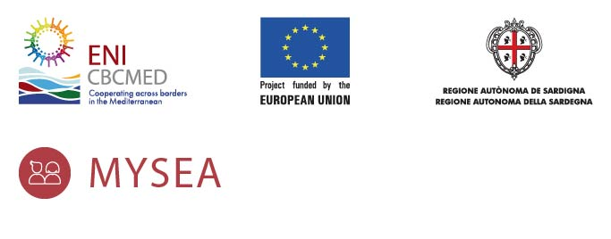
Press Release
______________________________________________________________________________
Promoting inclusive job-youth growth in the blue and green economy: EU-funded MYSEA project official launch
Five countries join forces to increase employability opportunities of 1000 youth, women and NEETs in the agri-food and waste management industries

The “Mediterranean Youth, NEETs and women advancing Skills, Employment and Awareness in the Blue and Green Economy – MYSEA” project is co-funded by the European Union under the ENI CBC MED Programme 2014-2020 and will be officially launched on February 15th 2021, 11h00 – 12h45 (Rome time) during a virtual press conference.

The MYSEA project involves 5 different countries: Greece, Italy, Lebanon, Jordan and Tunisia. These selected countries register the highest number of unemployed youths, young women and NEETs across the Mediterranean and share similar demographic changes, skill mismatches, rigid regulations and gender gaps.

The MYSEA implementing partners Centro Informazione e Educazione Allo Sviluppo - CIES (Italy – Lead), University of Palermo - Department of Agricultural, Food and Forest Sciences – UNIPA (Italy), Eurotraining Educational Organization SA (Greece), Lebanese Development Network - LDN (Lebanon), Tunisian Union of Social Solidarity - UTSS (Tunisia), Jordan University of Science and Technology - JUST (Jordan) will join their forces and cooperate to increase the employability of 1000 youth, women and NEETs in the agri-food and waste management industries by developing training oriented to both sectors and strengthening local governance and sector-skills alliances between economic actors and TVET institutions to align the education curricula with sector’s needs.
The kick-off press conference will see the participation of keynote speakers, among them, Mr Fabrizio Paloni, Coordinator of the Joint Technical Secretariat of the ENI CBC Med Programme; Paolo Orneli, Councillor of the Executive Board for Economic Development - Commerce and Crafts, Research, Start-Up and Innovation, Lazio Region (Italy); Mohamed Madhkour, Expert (Tunisia); Silvio Bologna, Researcher at University of Palermo (Italy); Yannis Lyeros, Training expert (Greece); Laury Haytayan and Dominique Salameh - Experts (Lebanon); Penelope Shihab - Private sector (Jordan). The discussion will focus on the need to understand and address the interrelated links that hinder social inclusion and gender equality. Hence the necessity to analyse the agrifood and waste management sectors within the green and blue economy, their modifying factors including the economic, social and environmental ones in order to exploit opportunities for economic growth and job creation, mitigate risks and steer attention and political interest.
MYSEA is a 30 months project, with a total budget of €3.6 million and it is financed by the European Union with a 90% contribution.

To find out more:
Kick off Press Conference Concept Note and Agenda

MYSEA official webpage
http://www.enicbcmed.eu/projects/mysea

ENI CBC Med program:
http://www.enicbcmed.eu/home
For more information, please contact:
In Italy:
Senior Project Manager, Lucia Conti
email: mysea.coordination@cies.it; phone +393391355531 +32470677267
Press Officer, Alessandro Bernardini
e-mail: mysea.communication@cies.it ; phone +39 333 493 2309
In Lebanon:
Senior Project Director, Amin Nehme
email: anehme@ldn-lb.org; phone +961 3445096
Communication Coordinator Antoinette Moubarak
e-mail: amoubarak@ldn-lb.org ; phone +961 76 176 580

______________________________________________________________________________
This document has been produced with the financial assistance of the European Union under the ENI CBC Mediterranean Sea Basin Programme. The contents of this document are the sole responsibility of CIES Onlus/LDN Lebanese Development Network - PP3 and can under no circumstances be regarded as reflecting the position of the European Union or the Programme management structures.

